PATIENT DETAILS:  Name of the patient | : XXX | Reporting Date/Time | : 22-04-2022; 15:46
Age | : 24 YEARS | Gender | : MALE
Referred by | : DR ALOK VASHISHTHA | Lab Code | : WIP001

TEST SAMPLE DETAILS:
Type of clinical sample | : EDTA PLASMA
Sample received Date/Time | : 11-04-2022; 12:15
Assay Code | : gDRI (GBL-17)

Report

Summary Data
Sequence includes PR: codons 1 - 99 Sequence includes RT: codons 1 - 388 Subtype: C (95.35%)

Technology
Reverse Transcription mediated Polymerase chain reaction and Automated DNA sequencing.

Drug Resistance Interpretation: PR
PI Major Resistance Mutations: None
PI Accessory Resistance Mutations: None
Other Mutations: T12S, L19I, M36I, R41K, D60E, L63P, H69K, I93L
Protease Inhibitors
atazanavir/r (ATV/r) | Susceptible
darunavir/r (DRV/r) | Susceptible
fosamprenavir/r (FPV/r) | Susceptible
indinavir/r (IDV/r) | Susceptible
lopinavir/r (LPV/r) | Susceptible
nelfinavir (NFV) | Susceptible
saquinavir/r (SQV/r) | Susceptible
tipranavir/r (TPV/r) | Susceptible

PR Comments
None
Mutation Scoring: PR
PI | ATV/r | DRV/r | FPV/r | IDV/r | LPV/r | NFV | SQV/r | TPV/r
Total | 0 | 0 | 0 | 0 | 0 | 0 | 0 | 0

Drug Resistance Interpretation: RT
NRTI Resistance Mutations: None NNRTI Resistance Mutations: None
Other Mutations:K11Q, V35T, T39S, V60I, D121H, K122E, I142T, K173T, Q174R, D177E, I178L, G196E, T200A, Q207E, V245K, A2 72P, V276I, E291D, V292I, I293V, G335D, P345T, R356K, M357R, G359A, S379C
Nucleoside Reverse Transcriptase Inhibitors
abacavir (ABC) | Susceptible
zidovudine (AZT) | Susceptible
stavudine (D4T) | Susceptible
didanosine (DDI) | Susceptible
emtricitabine (FTC) | Susceptible
lamivudine (3TC) | Susceptible
tenofovir (TDF) | Susceptible

Non-nucleoside Reverse Transcriptase Inhibitors
doravirine (DOR) | Susceptible
efavirenz (EFV) | Susceptible
etravirine (ETR) | Susceptible
nevirapine (NVP) | Susceptible
rilpivirine (RPV) | Susceptible

RT Comments
None

Mutation Scoring: RT

NRTI | ABC | AZT | D4T | DDI | FTC | 3TC | TDF
Total | 0 | 0 | 0 | 0 | 0 | 0 | 0
NNRTI | DOR |  | EFV | ETR | NVP |  | RPV
Total | 0 |  | 0 | 0 | 0 |  | 0

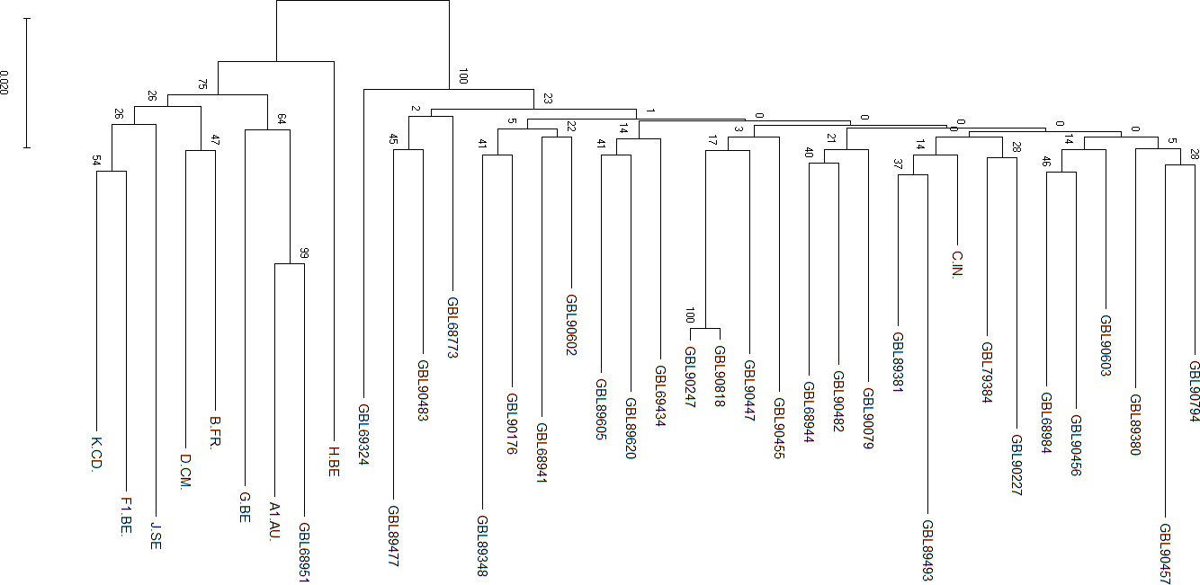
Phylogenetic Analysis to Verify Sequence Purity and Subtype Similarity

Fig.1. The phylogenetic tree of the test sample (GBL90818) with the different HIV-1 subtype reference sequences and recent
test samples sequences. The numbers at the node represent the percent bootstrap support for 500 replicates. Bars at the base of the tree show genetic divergence. Description of Phylogeny: Subtype/Sample name; Sample: (Subtype C)

Disclaimers: ‡The report represents only the specimen received in laboratory. ‡ PCR is a sensitive method, inconclusive and indeterminate results may be obtained due to presence of PCR inhibitory factors in the sample. Poor quality sample, delayed logistics and improper temperature conditions while sample transportation can affect the test results.

Interpretation algorithm: HIVdb Stanford.
This test has been developed at geneOmbio Technologies Pvt Ltd, Pune and its performance characteristics have been verified.
HIV-1 drug resistance interpretation assay from geneOmbio Technologies has successfully qualified EQAS from TreatAsia Bangkok ten
times since 2007.

-End of the report-

