**University of Iowa Hospitals and Clinics (UIHC)**

**Pharmacist Collaborative Practice Protocol**

Pre-Exposure Prophylaxis for HIV Service: IRL PrEP Clinic and TelePrEP

1. **Purpose & Goals**

**Purpose**

* The purpose of this protocol is to improve access to pre-exposure prophylaxis (PrEP) therapy and ensure safe and appropriate medication use for HIV prevention in patients at high risk of HIV acquisition. Collaborative care will be provided in-person, via MyChart and by phone, (IRL PrEP, TelePrEP) or by telemedicine(TelePrEP).

**Goals**

* To optimize medication management for patients at risk for HIV
* To monitor for adverse drug events from emtricitabine/tenofovir (Truvada® or Descovy®) and to prevent adverse outcomes
* To improve patient adherence to PrEP
* To improve knowledge of and adherence to laboratory monitoring required for PrEP therapy
* To reduce rates of HIV acquisition in high risk populations
* To eliminate geographical and stigma barriers in order to improve access to PrEP

**Telemedicine Technology**

TelePrEP video visits will be conducted using Vidyo®, a real-time video communication platform that adheres to HIPAA compliance security and encryption rules as defined by federal regulation. Vidyo® software is housed on UIHC servers and supported by HCIS. Visits are conducted by sending the patient a link that is compatible with operating systems of most smartphones, tablets, and personal computers. The patient can connect to the service using an ethernet connection, Wi-Fi, or cellular service. TelePrEP visits will be conducted as one-to-one video visits. The video connection link is patient-specific and active for only one clinic encounter.

1. **Providers Authorized**

Referral

* UIHC Providers
* Primary care providers working in Family Medicine, Internal Medicine, Women’s Health or Pediatrics. Consult must be placed (Appendix A). (IRL PrEP)
* Providers in the Infectious Diseases or Virology Clinic (TelePrEP)
* Public Health (TelePrEP)
* Referral from any Iowa county health department or community medical center
* Patient Self-Referral (TelePrEP)
* An individual who self-identifies as needing PrEP
* Individuals are not required to be seen by a UIHC provider prior to the TelePrEP visit.
* Truvada® or Descovy®, as prevention therapy, does not require a physician diagnosis or physical exam prior to initiation. Individuals who meet screening criteria for PrEP can be considered for PrEP once the required laboratory testing is completed.
* Patients new to the UIHC system will be registered as new patients prior to the initial visit and will sign the required HIPAA policy. The TelePrEP medical director will become the physician of record for the patient.

Pharmacists

* Pharmacists working within the IRL Internal Medicine PrEP Clinic may provide care to patients pursuant to this protocol.
* Pharmacists working within the TelePrEP telemedicine service may provide care to patients pursuant to this protocol.

1. **Responsibilities Authorized by this Protocol**

Pharmacist Scope of Practice

* See the Patient Screening, Assessment, and Monitoring algorithm in Appendix B
* Patient Screening
  + The pharmacist will assess the patient for appropriateness of PrEP (Appendix C).
  + All attempts will be made to obtain local public health assessments for HIV risk prior to the initial visit. When available, local medical records and UIHC Epic documentation will also be reviewed.
  + In addition to the behavioral risk assessment (Appendix C), the initial visit will include a review of the patient’s current medical conditions, medications, allergy history, and substance use.
* All Patients will receive risk avoidance counseling. Those who are not candidates for Truvada® or Descovy® as pre-exposure prophylaxis will be referred to appropriate healthcare and public health services.
* Patients who are eligible for Truvada® or Descovy®, but with immediate risk (high risk exposure within past 2 weeks) require consultation with the consulting provider (IRL PrEP) or medical director (IRL PrEP/TelePrEP) for consideration of acute HIV diagnosis,and possible post-exposure prophylaxis (PEP) as indicated by timing of exposure. Upon completion of PEP, and confirmation of a negative HIV test, PrEP may be initiated.
* Patient Assessment
  + The pharmacist will assess medication adherence, side effects and sexual risk behaviors at baseline, at least every 3 months, and more frequently when indicated (Appendix D).
  + Monitoring visits will also include a brief review of the patient’s health changes, medications, and substance use.
  + The pharmacist will discuss/assess the need for ongoing therapy with the patient at least annually.
* Medication Therapy Management
  + The pharmacist may initiate or discontinue emtricitabine (FTC) 200 mg/ tenofovir disoproxil fumarate (TDF) 300 mg (Truvada®) or emtricitabine (FTC) 200 mg/tenofovir alafenamide (TAF) 25 mg (Descovy®) on behalf of the referring provider or medical director.
* Truvada® is indicated to reduce the risk of sexually acquired HIV-1 in at-risk adults and adolescents weighing at least 35 kg.
* Descovy® is indicated in at-risk adults and adolescents weighing at least 35 kg for PrEP to reduce the risk of HIV-1 infection from sexual acquisition, excluding individuals at risk from receptive vaginal sex.
* Only patients with a negative HIV test AND CrCl ≥ 60 ml/min will be prescribed Truvada® for PrEP
* Only patients with a negative HIV test AND CrCl > 30 ml/min will be prescribed Descovy® for PrEP.
* Descovy® is indicated in at-risk adults and adolescents weighing at least 35 kg for PrEP to reduce the risk of HIV-1 infection from sexual acquisition, excluding individuals at risk from receptive vaginal sex.
* PrEP Dose: Truvada® 1 tablet (containing FTC 200 mg/ TDF 300mg) or Descovy® 1 tablet (containing FTC 200 mg/TAF 25 mg) orally daily with or without food
* No dosage adjustment is required in individuals with CrCl ≥ 60 ml/min for Truvada® or > 30 ml/min for Descovy®
  + The pharmacist may issue prescription renewals on behalf of the referring provider or medical director for emtricitabine/tenofovir (Truvada® or Descovy®).
* Truvada® or Descovy® prescriptions will be for no more than 90 days (until the next HIV test).
* Patients off Truvada® or Descovy® for > 7 days will need to undergo the required clinical assessment and laboratory testing before Truvada® or Descovy® can be restarted or renewed.
* Laboratory Monitoring
  + The pharmacist will order appropriate baseline and follow-up laboratory tests under the referring provider or medical director (see Appendix D).
* Pre-prescription and monitoring laboratory testing will follow the most recent USPHS/CDC guidelines for PrEP. (Appendix D),and/or the Truvada® or Descovy® prescriber package insert as appropriate
* Documented serum creatinine and HCV serology within the past 6 months may be used for the initial assessment. HIV and pregnancy screening must be done within 7-14 days of the PrEP assessment in order to be considered for PrEP medication.
* For patients requiring off-site labs, orders will be sent the patient’s preferred lab or public health site where testing can be completed. Collaboration with local public health departments may be necessary to coordinate lab draws in order to maintain patient privacy, especially in rural areas.
* Positive laboratory tests, including HIV, HBV, HCV, syphilis and pregnancy, require consultation with the consulting provider or Medical Director, or their designee for the plan of care.
* Positive gonorrhea or chlamydia laboratory tests may be managed by the pharmacist according to Appendix E.
* Vaccinations
  + The pharmacist may order vaccinations for Hepatitis A, Hepatitis B, and human papillomavirus (HPV) on behalf of the referring provider or medical director, as indicated by the screening assessment, and according to [The Advisory Committee on Immunization Practices (ACIP) guidelines](http://www.cdc.gov/vaccines/hcp/acip-recs/).
* Patient Education:
* The Pre-Prescription Patient Education Checklist (Appendix F) may be used as a discussion guide.
* Education will be provided verbally and written handouts provided as appropriate.
  + Written Education may be provided through FDA approved [Risk Evaluation and Mitigation Strategies (REMS) medication information](http://www.truvadapreprems.com/truvadaprep-resources) or [CDC education documents](http://www.cdc.gov/hiv/basics/prep.html) regarding risks and benefits of Truvada®.
* Education will include the following:
  + Medication Education
    - Efficacy
    - Dosing and administration
    - Importance of adherence
    - Duration of therapy
    - Storage and handling
    - Adverse effects and what to do if they occur
    - Time to protection
    - Monitoring
    - Signs and symptoms of acute HIV infection
  + Safer-sex counseling
  + Process for lab monitoring and obtaining medication refills
  + TelePrEP patients will be educated on the use of Vidyo® for clinical visits and provided with tips to optimize the video connection.

UIHC Internal Medicine, Family Medicine Provider Responsibilities

* The referring provider is responsible for the general supervision of the patient’s care and must maintain an ongoing relationship (i.e. minimum of an annual clinic visit) with the patient in order for the patient to receive care pursuant to this protocol.
* The referring provider will be available to discuss care pursuant to this protocol if needed. In the event the referring provider is unavailable, then the medical director of the protocol will be contacted.
* The referring provider may withdraw the patient from the protocol at any time or may override this protocol whenever he or she deems such action necessary or appropriate for a specific patient.

Medical Director Responsibilities

* The medical directors of the IRL PrEP Clinic (Nicole Nisly, MD) and TelePrEP (Michael Ohl, MD, MSPH), or their designee, will oversee the responsibilities of the pharmacists and providers operating under this protocol and will be available to the pharmacist for consultation when needed.

1. **Documentation/Communication**

* The pharmacist and/or the provider shall inform the patient that care will be provided collaboratively pursuant to this collaborative practice agreement.
* The pharmacist shall document in the patient’s electronic medical record the patient has been referred to collaborative care pursuant to this protocol.
* The pharmacist shall document all interventions and activities appropriately in the patient’s electronic medical record.
  + The pharmacist will sign the clinic note as the final reviewer and notify the medical director verbally or electronically as needed.
* Circumstances that shall cause the pharmacist to initiate communication with the provider or medical director:
  + A positive HIV, HBV, HCV, syphilis or pregnancy test
  + Critical laboratory results or concerning results based on the professional judgment of the pharmacist
  + Adverse drug reaction necessitating physician evaluation in the professional judgment of the pharmacist
  + The patient is being discharged from the pharmacist’s collaborative care pursuant to the established protocol for any of the following reasons:
    - The patient has elected not to start or to discontinue emtricitabine/tenofovir (Truvada® or Descovy®).
    - The patient has failed to maintain consistent follow-up and laboratory monitoring with the pharmacist providing care pursuant to this agreement (remaining refills will be discontinued at pharmacy).
* The patient’s medication list within the electronic medical record will be updated to reflect any therapy changes.
* If a medication error occurs, it will be reported per UIHC protocol.

1. **Quality Assurance**

* A subset of patient medical records will be audited for appropriate documentation on a routine basis.
* On an annual basis, the medical director or his/her designee will review 2 clinic notes per pharmacist to confirm that appropriate care is being provided pursuant to this protocol.
* This protocol will be reviewed and updated annually or more frequently based on changes in clinical practice.

1. **Pharmacist Training and On-going Competency**

* Each new pharmacist who provides care pursuant to this protocol will be trained and evaluated during an orientation period. Therapeutic plans and electronic notes will be reviewed during the orientation period as part of that evaluation.

1. **Related Standard(s)**

[PC-PCI-05.54, “Pharmacist and Physician Participation in Collaborative Drug Therapy Management”](https://thepoint.healthcare.uiowa.edu/sites/Policies-UIHCPolicies/Provision%20of%20CarePatient%20Care/Patient%20Care%20Issues/PC-PCI-05.54.doc)

1. **References**

1. US Public Health Service. Preexposure prophylaxis for the prevention of HIV infection in the United States — 2017Update: A clinical practice guideline. <https://www.cdc.gov/hiv/pdf/risk/prep/cdc-hiv-prep-guidelines-2017.pdf>. Published March 2018.

2. Center for Disease Control and Prevention: US Public Health Service: Preexposure prophylaxis for the prevention of HIV infection in the United States — 2017 Update: clinical providers’ supplement. <https://www.cdc.gov/hiv/pdf/risk/prep/cdc-hiv-prep-provider-supplement-2017.pdf>. Published March 2018.

3. New York State Department of Health AIDS Institute. PrEP to prevent HIV and Promote Sexual Health. October 2019. [www.hivguidelines.org/prep-for-prevention/prep/](http://www.hivguidelines.org/prep-for-prevention/prep/)

4. Truvada® package insert, updated 5/2018; accessed 11/11/19

5. Descovy® package insert, updated 10/2019; accessed 11/11/19.

6. Hare, C. The Phase 3 DISCOVER Study: Daily F/TAF or F/TDF for HIV Pre-exposure Prophylaxis. CROI 2019, Abstract 104.

**IX. Signatures**

*Signed hard copy available, contact Jamie Smelser @ 3-7376*

|  |  |  |  |  |
| --- | --- | --- | --- | --- |
| |  |  | | --- | --- | | _____________________________________  Date  _____________________________________ | _____________________________________  Date  _____________________________________ | | Michael Ohl, MD, MSPH  Associate Professor of Internal Medicine –  Infectious Diseases  Medical Director, TelePrEP Service  University of Iowa Hospitals and Clinics | Nicole Nisly, MD  Clinical Professor  Internal Medicine  Director, IRL PrEP Clinic  University of Iowa Hospitals and Clinics | |
|  |

|  |  |  |
| --- | --- | --- |
| Date |  | Date |
| Michael Brownlee, PharmD, MS Chief Pharmacy Officer  Co-Chair, Pharmacy & Therapeutics Working Group  University of Iowa Hospitals and Clinics |  | Jason Wilbur, MD  Clinical Associate Professor Family Medicine  Co-Chair, Pharmacy & Therapeutics Working Group  University of Iowa Hospitals and Clinics |

Date created: 10/7/2016

Source: Department of Pharmaceutical Care

Date of Pharmacy and Therapeutics Subcommittee approval: 11/22/2016; 1/23/2018; 11/26/2019; 7/28/2020

Date effective: 11/22/2016

Date Revised: December 2017; November 2019; June 2020

**Appendix A: IRL PrEP Consult**

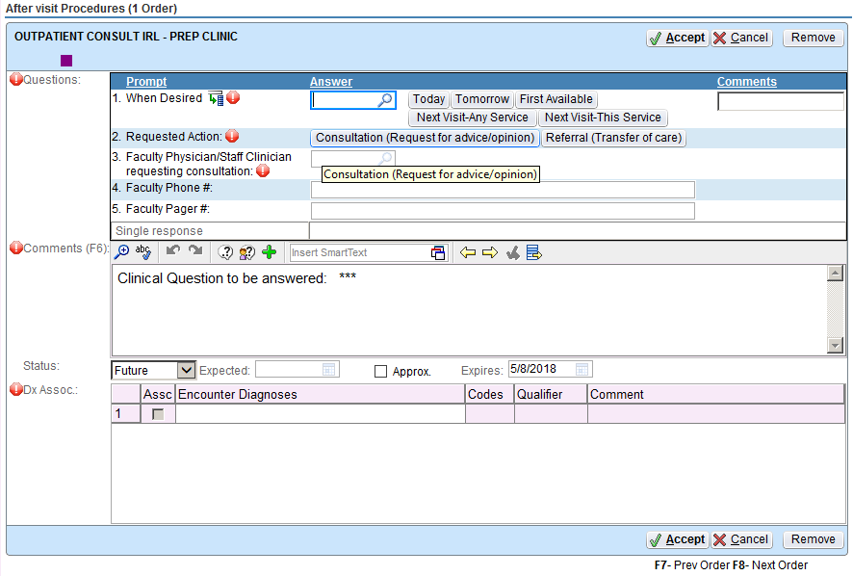

**Appendix B: Screening, Treatment, & Monitoring Algorithm**

Consult with Medical Director

+ gonorrhea or chlamydia

Positive Syphilis

Yes

Family Medicine

Internal Medicine

HIV Clinic

Public Health Referral

Self-Referral

Send Vidyo Link

Serum Cr ± UA

No

Yes

No

Yes

No

Pregnancy Positive?

Yes

HIV, HBV, HCV Positive?

STI Positive?

No

Candidate for HAV, HBV, or HPV Vaccine?

Yes

Vaccinations

Consult with Medical Director

90-day supply

Rx Renewal

Yes

No

Initial Rx

Truvada or Descovy Rx

Initial Assessment

Labs

Interview

30-day supply with 2 refills

**Truvada or Descovy Candidate?**

**Clcr ≥ 60 or 30 ml/min?**

**Appendix C: Guidance for PrEP & Risk Assessment**

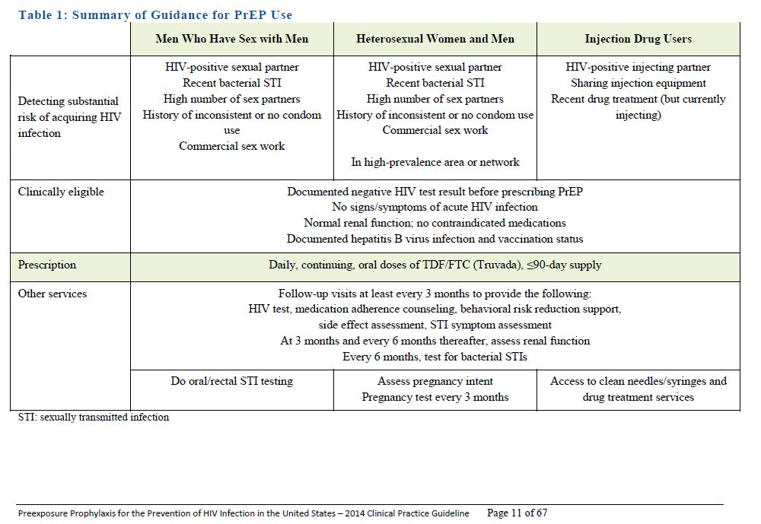

Source: US Public Health Service. Preexposure prophylaxis for the prevention of HIV infection in the United States — 2017Update: A clinical practice guideline. <https://www.cdc.gov/hiv/pdf/risk/prep/cdc-hiv-prep-guidelines-2017.pdf>. Published March 2018.

**Appendix D: Monitoring Schedule**

**Screening & Monitoring for PrEP Therapy**

|  |  |  |  |  |  |
| --- | --- | --- | --- | --- | --- |
|  | **Screening Assessment (Pre-prescription)** | **Within 1st month of starting PrEP** | **At least every**  **3 months** | **At least every**  **6 months** | **At least every**  **12 months** |
| Sexual history, risk for HIV | **√** |  | √1 |  |  |
| HIV test, assess for acute infection2,3 | √ |  | √ |  |  |
| Hepatitis B serology4 | √ |  |  |  | √ |
| Hepatitis C | √ |  |  |  | √5 |
| Serum creatinine & creatinine clearance | √6 |  | √7 | √ |  |
| STI testing8 | √ |  | √8 | √ |  |
| Pregnancy test9 | √ |  | √ |  |  |
| Medication adherence |  | √ | √ |  |  |
| Medication adverse events |  | √ | √ |  |  |

**√** = guideline recommendation √ = optional, based on individual risk

1. Risk behaviors and ongoing risk.
2. Acute and chronic HIV infection must be excluded by symptom history and HIV testing immediately before PrEP is prescribed.

* Symptoms of acute HIV infection: fever, fatigue, myalgia, skin rash, headache, pharyngitis, lymphadenopathy, arthralgia, night sweats, and diarrhea.
* Clinicians should document a negative antibody test result within 1 week of initiating medication (2 weeks for TelePrEP)
* HIV testing
* Blood draw (serum) and lab testing for antigen/antibody or antibody only OR
* 4th generation rapid/POC test
* Oral fluid rapids tests (eg. OraQuick) should only be used for follow up visits if it is highly unlikely or impossible to a get a blood test due to limited access to testing due to disruptions of healthcare delivery related to COVID-19 or other reasons (per [CDC guidance](https://www.cdc.gov/hiv/policies/dear-colleague/dcl/051520.html?fbclid=IwAR1YxxNHJntfHJTxYEV7KJvuKQ0pcej1SO7Ok9Hk0OyvBF0iWqPTpaYWcEg)) . Oral tests should NOT be used to initiate treatment. A blood HIV test must be completed within 30 days of the saliva test.

1. HIV infection should be assessed at least every 3 months so that those with incident HIV infection are treated appropriately. Truvada® or Descovy® alone is inadequate therapy for established HIV infection.
2. HBsAg at minimum prior to starting Truvada® or Descovy®. Preferred serology: HBsAg, HBsAb, HBcoreAb (Total IgM & IgG). HBsAg should be monitored annually in people without documented HBV immunity. HBV vaccination recommended, especially for MSM.
3. Annual HCV retesting for people with injection drug use. Consider annual retesting for others with ongoing risk of HCV exposure.
4. Do not initiate or continue Truvada®, as PrEP, in individuals with a creatinine clearance < 60 mL/minute, based on Cockcroft-Gault formulas. Do not initiate or continue Descovy®, as PrEP, in individuals with a creatinine clearance < 30 mL/minutes.
5. Consider for patients with borderline renal function or risk factors for renal disease (e.g. HTN, Diabetes)
6. Syphilis. Chlamydia, gonorrhea – genital, rectal, and oropharyngeal testing as indicated. Every 3 month testing recommended for persons with signs/symptoms of infection and for asymptomatic MSM at high risk for bacterial STIs (e.g. condom use < 100%, receptive anal sex without condom use).
7. Repeat pregnancy testing for women who may become pregnant. If a patient takes PrEP while pregnant or becomes pregnant during utilization of PrEP, providers are encouraged to prospectively and anonymously submit information about the pregnancy to the *Antiretroviral Use in Pregnancy Registry*. Pregnancy test can be waived for women with documented hysterectomy or tubal ligation.

Source: US Public Health Service. Preexposure prophylaxis for the prevention of HIV infection in the United States — 2017 update: A clinical practice guideline. Published March 2018. (<https://www.cdc.gov/hiv/pdf/risk/prep/cdc-hiv-prep-guidelines-2017.pdf>)

**Appendix E: STI treatment algorithm**

Sources: Centers for Disease Control and Prevention 2015 STD Treatment Guidelines, WHO Guidelines for the Treatment *Neisseria gonorrhea* and *Chlamydia trachomatis* 2016

Non-response to 1st line treatment will result in consultation with the Medical Director.

Second line treatment for gonorrhea using oral cefixime may be administered for infection of the cervix, urethra, or rectum when access to IM ceftriaxone is not feasible. IM ceftriaxone is the preferred treatment for all gonorrhea infections.

Regimen:

Cefixime 400 mg orally in a single dose PLUS Azithromycin 1 gram orally in a single dose.

**Appendix F: Patient Education**

**Pre-Prescription Patient Education Checklist**

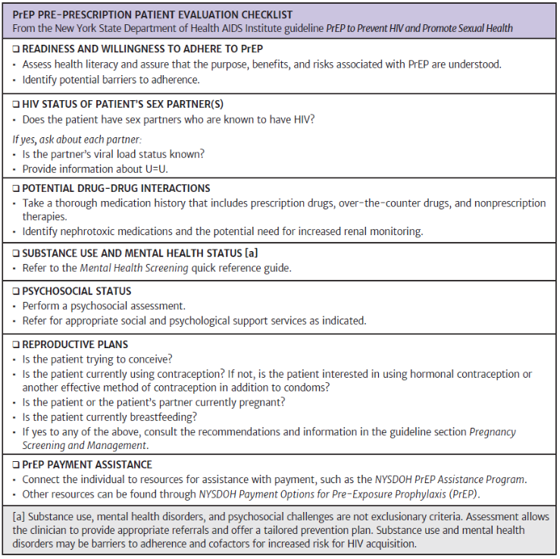

New York State Department of Health AIDS Institute. PrEP to prevent HIV and Promote Sexual Health. October 2019. [www.hivguidelines.org](http://www.hivguidelines.org)/prep-for-prevention/prep/