HYACINTH HEALTH AND WELLNESS CENTER
POLICY AND PROCEDURE
ORIGINAL DATE: | REVIEW & REVISION DATES:
TITLE:  TELE-MEDICINE PROTOCOL ON PrEP TREATMENT/ MANAGEMEMNT. | APPROVALS:
 | MEDICAL DIRECTOR/APN: | DATE:
 | CLINIC DIRECTOR: | DATE:
 | EXECUTIVE DIRECTOR: | DATE:

POLICY

PrEP is short for pre-exposure prophylaxis. It is the use of antiretroviral medication to prevent acquisition of HIV infection. PrEP is used by people without HIV who are at risk of being exposed to HIV through sexual contact or injection drug use. Two medications have been approved for use as PrEP by the FDA. Each consists of two drugs combined in a single oral tablet taken daily:
- Emtricitabine (F) 200 mg in combination with tenofovir disoproxil fumarate (TDF) 300 mg (F/TDF – brand name Truvada®)
- Emtricitabine (F) 200 mg in combination with tenofovir alafenamide (TAF) 25 mg (F/TAF – brand name Descovy®)
These medications are approved to prevent HIV infection in adults and adolescents weighing at least 35 kg (77 lb) as follows:
- Daily oral PrEP with F/TDF is recommended to prevent HIV infection among all persons at risk through sex or injection drug use.
- Daily oral PrEP with F/TAF is recommended to prevent HIV infection among persons at risk through sex, excluding people at risk through receptive vaginal sex. F/TAF has not yet been studied for HIV prevention for receptive vaginal sex.
PrEP should be considered part of a comprehensive prevention plan that includes a discussion about adherence to PrEP, condom use, other sexually transmitted infections (STIs), and other risk reduction methods (CDC.GOV)

TELE-MEDICINE- Telehealth, telemedicine, and related terms generally refer to the exchange of medical information from one site to another through electronic communication to improve a patient’s health. Innovative uses of this kind of technology in the provision of healthcare is increasing (cms.gov).

TYPES OF VIRTUAL SERVICES

TELEHEALTH VISITS: This is the use of telecommunication technology for office, hospital visits and other services that generally occur in-person.
VIRTUAL CHECK-INS: A brief communication service with practitioners via a number of communication technology modalities including synchronous discussion over a telephone or exchange of information through video or image.

E-VISITS: Patients having non-face-to-face patient-initiated communications with their doctors without going to the doctor’s office by using online patient portals.

HEALTH INSURANCE PORTABILITY AND ACCOUNTABILITY ACT (HIPAA)

Effective immediately, the HHS Office for Civil Rights (OCR) will exercise enforcement discretion and waive penalties for HIPAA violations against health care providers that serve patients in good faith through everyday communications technologies, such as FaceTime or Skype, during the COVID-19 nationwide public health emergency. For more information: https://www.hhs.gov/hipaa/for-professionals/special-topics/emergency-preparedness/index.html

INFORMED CONSENT

In telehealth, informed consent is used to explain what telehealth is, lay out the expected benefits and possible risks associated with it to a patient, and explain security measures. It often requires a written form which needs to be signed by the patient and/or oral acknowledgement that is noted in the patient’s record.

All Clients requesting for telemedicine management MUST sign the informed consent form for telemedicine at the initial visit encounter.

BENEFITS OF PREP TELEMEDICINE
- PrEP telehealth can increase PrEP access for those most vulnerable to HIV who may not otherwise have access due to social stigma or distance from the closest PrEP provider.
- Because telehealth allows patients to have virtual provider visits, it can alleviate some of the difficulties surrounding geographic isolation, such as in rural areas, or reluctance to access PrEP because of fear of stigma.
- Telehealth can also reduce PrEP delivery barriers related to local health care professional shortages since, again, patients do not necessarily have to physically visit a provider.
- A third advantage of PrEP telehealth is that it can support patients who struggle with medication adherence.
- The development and use of real-time electronic adherence monitors, digital medicine systems, and short message service (SMS) surveys in PrEP research illustrates technology advances that may improve adherence measurements.
- In the future, the use of PrEP telehealth could mean intervening and improving adherence to PrEP in real time.

PROCEDURE

Initial PrEP Management Encounter at the Clinic site.

Initial management and care of PrEP clients MUST be initiated at the clinic to allow for initial history taking, assessment and presentation of treatment guidelines.

All clients presenting with symptoms of Sexually Transmitted Infection (STI) or asking to be treated for an STI should have a sexual health history taken and a discussion on HIV Risk, and HIV Prevention (PrEP). To screen and or treat the patient for STIs, see the HYACINTH Tele-medicine STI screening and treatment guidelines.

New Clients requesting for PrEP treatment, or for those clients recommended for PrEP based on their history, determined to be at risk for HIV should:

Have a documented negative lab result for HIV; this can be done at the clinic site using Point-of-Care rapid HIV test, followed by a negative HIV Ag/Ab lab result obtained from a well-known laboratory office i.e. LabCorp.

No signs/ Symptoms of acute HIV infection.

Normal renal function and no contraindicated medications.

Documented hepatitis B virus infection and vaccinations status.

Have appropriate STI testing done and sent to the lab, including specimen collection at all body parts that have had sexual contact- i.e., urogenital collection with urine, vaginal swab, and/or extragenital self-swabs of the throat and/or rectum accompanied by an order sent to the lab.

Self-swab instructions are attached to this protocol and will be made available in all HYACINTH PrEP centers.

At the clinical site, the lab slip can be printed and sent with the collected self-swab specimens that the client collected in the clinic restroom.

Other labs for New PrEP clients include: RPR, HCV, HBV surface antigen and HBV quantitative antibody test, creatinine clearance, CBC, CMP.

Discussion on the risk of HIV and STIs shall take place during this initial encounter and subsequent encounter with clients and discussion for prescription for either Truvada or Descovy as well as pharmacy choice after verification of negative HIV test.

Discussion regarding adherence, the uncommon but possible adverse effects, and the need to be seen at least every 3 months for follow up and confirmed negative HIV test in order to continue with PrEP medication.

Option for Tele-medicine shall also be discussed and documented.

PrEP Tele- Medicine Treatment Management Guidelines
After the initial encounter of PrEP treatment management at the clinical site, subsequent follow up can be done by tele-medicine via telephone consultation or video consultation as preferred by the client, using the CDC PrEP management guidelines:
Guidelines as follow:

PrEP client shall have a follow up visit every THREE months to validate continuation with PrEP treatment and documented negative HIV result.

Clients shall pick up a bag of the specimen collection containers at the clinic after the initial encounter as well as appropriate Lab slip for the scheduled three-month appointment.

All collected specimens shall be brought to the clinic two week before clients scheduled appointment and the nursing staff or the PrEP Navigator shall verify that all specimen containers have patient name and source of specimen before sending to the designated lab.

Clients who does not complete their lab as requested will be DENIED access to medication refills.

PrEP navigator staff MUST follow up with PrEP clients in regards to treatment and follow up.

The clinic nurse/ PrEP navigator shall call PrEP client two weeks before schedule appointment to remind them of their follow up lab and appointment date.

The clinic nurse/ PrEP navigator shall provide proper education for clients in regards to specimen collection.

The clinic nurse/PrEP navigator shall evaluate clients learning and make appropriate recommendations.

The clinic nurse/ PrEP navigator shall maintain appropriate follow up with clients according to PrEP guideline protocol and Hyacinth clinic policy.

Addendum: Attached provider checklist and client’s information must be signed, documented as part of clients’ chart and one copy given to client.

Initial PrEP Clinical Guideline:

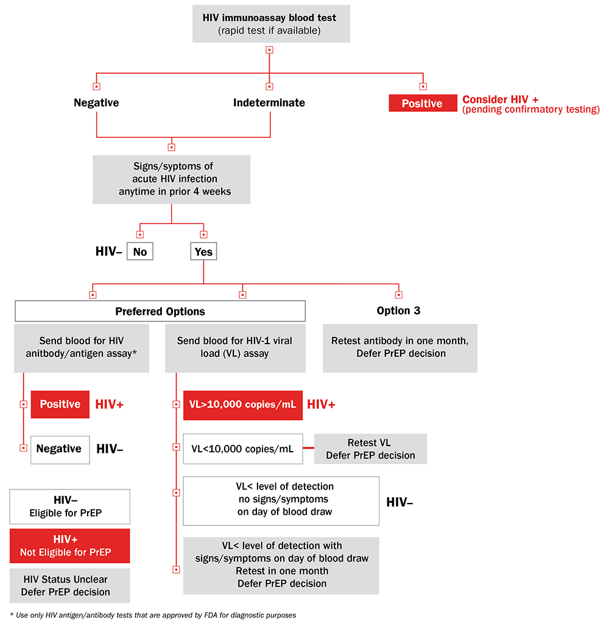

HYACINTH AIDS/HIV FOUNDATION
CHECKLIST FOR INITIATING PREEXPOSURE PROPHYLAXIS (PrEP)

_________________________________ __________________________________
Print name of provider Print name of patient

_________________________________ Today’s date (month/day/year)
Provider Section
I have provided this patient with the following: (check all as completed):
- Assessment for possible acute HIV infection
- Indicated laboratory screening to determine indications for these medications
- An HIV risk assessment to determine whether PrEP is indicated for this patient
- A medication fact sheet listing dosing instructions and side effects
- Counseling or a referral for counseling on condom use and any other HIV risk- reduction methods this patient may need
- Advice on methods to help the patient to take medication daily as prescribed
- Information about PrEP use during conception and pregnancy (when indicated)
- A prescription for Truvada (300 mg tenofovir disoproxil fumarate, 200 mg emtricitabine) or Emtricitabine (F) 200 mg in combination with tenofovir alafenamide (TAF) 25 mg (F/TAF – brand name Descovy.
- A follow-up appointment date
As the provider, I will:
• Limit refill periods to recommended intervals for repeat HIV testing (at least every 3 months).
- Conduct follow-up visits at least every 3 months that include the following:
o Assessment of HIV status (including signs or symptoms of acute HIV infection).
o Assessment of side effects and advice on how to manage them.
o Assessment of medication adherence and counseling to support adherence.
o Assessment of STI symptoms, HIV risk behavior and counseling support for risk- reduction practices.
- Inform the patient of any new information about PrEP and respond to questions.

Patient Section
It has been explained to me that:
- Taking a dose of PrEP medication every day may lower my risk of getting HIV infection.
- This medicine does not completely eliminate my risk of getting HIV infection, so I need to use condoms during sex.
- This medicine may cause side effects so I should contact my provider for advice by calling ________________ if I have any health problems.
- It is important for my health to find out quickly if I get HIV infection while I’m taking this medication, so
o I will contact my provider right away if I have symptoms of possible HIV infection (fever with sore throat, rash, headache, or swollen glands)
- My provider will test for HIV infection at least once every 3 months
Therefore, I will:
- Try my best to take the medication my provider has prescribed every day.
- Talk to my provider about any problems I have in taking the medication every day.
- Not share the medication with any other person.
- Attend all my scheduled appointments.
- Call _________________ to reschedule any appointments I cannot attend
Give one copy to patient

National Center for HIV/AIDS, Viral Hepatitis, STD, and TB Prevention Division of HIV/AIDS Prevention

Summary of Guidance for PrEP Use
 | Men Who Have Sex With Men | Heterosexual Women and Men | Injection Drug Users
Detecting substantial risk of acquiring HIV infection: | - Sexual partner with HIV  - Recent bacterial STD  - High number of sex  partners  - History of inconsistent or  no condom use  - Commercial sex work | - Sexual partner with HIV  - Recent bacterial STD  - High number of sex  partners  - History of inconsistent or  no condom use  - Commercial sex work  - Lives in high-prevalence  area or network | - HIV-positive injecting partner  - Sharing injection equipment  - Recent drug treatment (but currently injecting)
Clinically eligible: | - Documented negative HIV test before prescribing PrEP  - No signs/symptoms of acute HIV infection  - Normal renal function, no contraindicated medications  - Documented hepatitis B virus infection and vaccination status
Prescription | Daily, continuing, oral doeses of TDF/FTC (Truvada), ≤90 day supply  OR  Daily oral dose of Emtricitabine (F) 200 mg in combination with tenofovir alafenamide (TAF) 25 mg (F/TAF – brand name Descovy.
Other services: | - Follow-up visits at least every 3 months to provide:  - HIV test, medication adherence counseling, behavioral risk reduction support,  side effect assessment, STD symptom assessment  - At 3 months and every 6 months after, assess renal function  - Every 6 months test for bacterial STDs
 | • Do oral/rectal STD testing | - Assess pregnancy intent  - Pregnancy test every 3  months | • Access to clean needles/ syringes and drug treatment services
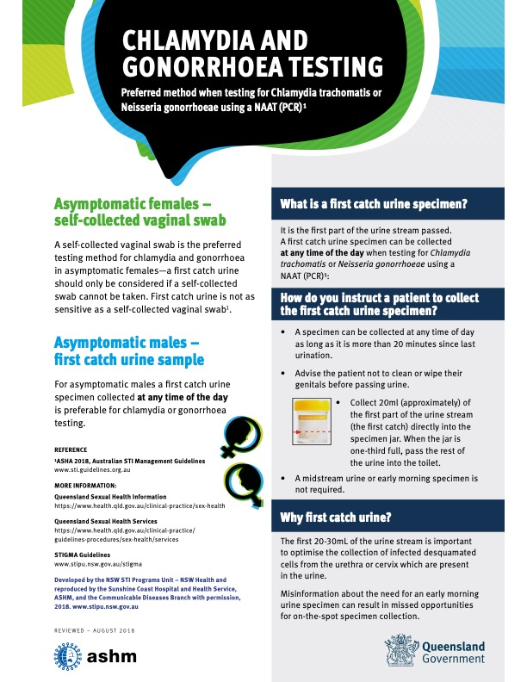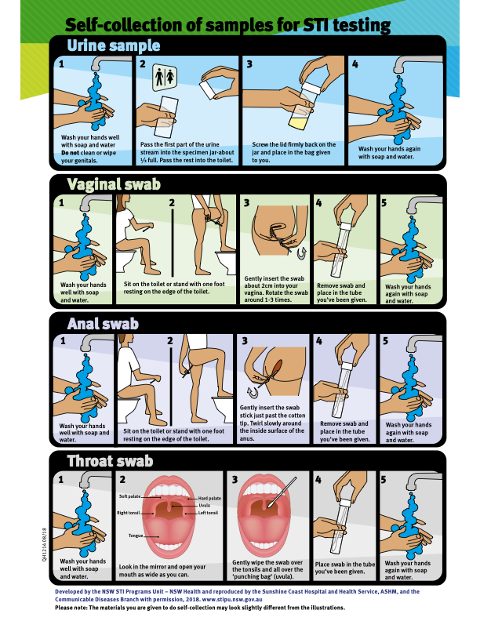

UP-TO-DATE GUIDELINES FOR PREP MANAGEMENT/ RESOURCES
Current U.S. Public Health Service guidelines and treatment protocols for managing PrEP. Guidelines on this page are revised as USPHS guidelines are updated.

PrEP Guidelines
- Preexposure Prophylaxis for the Prevention of HIV Infection in the United States – 2017 Update
Open PDF | From The CDC MMWR
- Clinical Providers’ Supplement: Preexposure Prophylaxis for the Prevention of HIV Infection in the United States – 2017 Update
Open PDF | From The CDC MMWR

